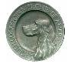
SPANIEL CLUB OF AMERICA
2023 NATIONAL COCKER CHAMPIONSHIP

Dear Cocker Enthusiast,

The 2023 NATIONAL COCKER CHAMPIONSHIP will be held this year at
Robert E. Talbot Conservation Area; La Russel, Missouri.. It will commence on Wednesday, December 6 and run until conclusion estimated to be December 9, 2023

A great way to become a part of the Championship is to be a PATRON!
The generous support of our patrons over the years has contributed greatly to the success of the event! Please consider being a patron for our 20123 National Championship.

Platinum - $500.00 or more
Exclusive patron gifts for (2) people.

Banquet dinner for (2) people.
Lunches each day for (2) people.
National Event catalogs (2)
Acknowledgement in the 2023 NCC catalog
50% discount on advertising in the 2023 NCC catalog
Best Seats in the House – option to Shag ALL series

Gold - $400.00
Exclusive patron gift for (1) person.
Banquet dinner for (1) person.
Lunches each day for (1) person
National event catalog (1)
Acknowledgement in the 2023 NCC catalog
25% Discount on advertising in the 2023 NCC catalog
Best Seat in the house – option to Shag Series 1-4

Silver - $200.00
Banquet dinner for (1) person
Lunches each day for (1) person
National event catalog (1)
Acknowledgement in the 2023 catalog
10% Discount on advertising in the 2023 NCC catalog
Best Seats in the house – option to Shag series 1-2

Bronze - $100.00
National event catalog
Acknowledgement in the 2023 catalog

Please send you check payable to ECSCA/NCC 2023 – Deb Strohl
N2286 Shore Drive, Marinette, WI 54143. By November 01, 2023.

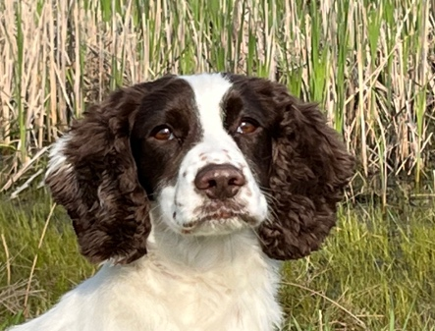

NFC, FC Fallen Wings Cassandra of Triple Ridges “SANDY”

Owners: Faye & Barry Littlewood
Handler: Ralph Botti

2023 FIELD TRIAL COM M ITTEE

Ron Bullock
FTC Chair
ronbull68@gmail.com

Ted McCue
Eastern Region
tedmccue@gmail.com

Susan Sarracino-Deihl
Central Region
saracen@wi.rr.com

John Alstad
Member At Large
john.alstad@minot.k12.nd.us

Jack Glinsky
Member At Large jglinsky@optonline.net

Dave Williams
Member At Large
davidwilliams525@
hotmail.com

“Doing My Part”

www.fieldcockers.com

